Task1

|  |  |  |  |  |  |  |  |  |  |  |
| --- | --- | --- | --- | --- | --- | --- | --- | --- | --- | --- |
| D7 | D6 | D5 | D4 | D3 | D2 | D1 | D0 | A2 | A1 | A0 |
| 0 | 0 | 0 | 0 | 0 | 0 | 0 | 0 | 0 | 0 | 0 |
| 0 | 0 | 0 | 0 | 0 | 0 | 1 | X | 0 | 0 | 1 |
| 0 | 0 | 0 | 0 | 0 | 1 | X | X | 0 | 1 | 0 |
| 0 | 0 | 0 | 0 | 1 | X | X | X | 0 | 1 | 1 |
| 0 | 0 | 0 | 1 | X | X | X | X | 1 | 0 | 0 |
| 0 | 0 | 1 | X | X | X | X | X | 1 | 0 | 1 |
| 0 | 1 | X | X | X | X | X | X | 1 | 1 | 0 |
| 1 | X | X | X | X | X | X | X | 1 | 1 | 1 |

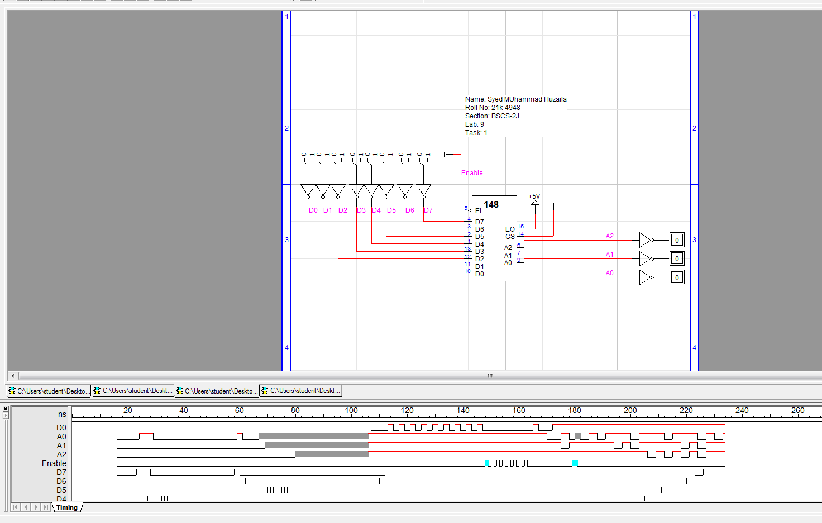

Task 2

|  |  |  |  |  |  |  |  |  |  |  |  |  |
| --- | --- | --- | --- | --- | --- | --- | --- | --- | --- | --- | --- | --- |
| D8 | D7 | D6 | D5 | D4 | D3 | D2 | D1 | D0 | D | C | B | A |
| 0 | 0 | 0 | 0 | 0 | 0 | 0 | 0 | 1 | 0 | 0 | 0 | 1 |
| 0 | 0 | 0 | 0 | 0 | 0 | 0 | 1 | 0 | 0 | 0 | 1 | 0 |
| 0 | 0 | 0 | 0 | 0 | 0 | 1 | 0 | 0 | 0 | 0 | 1 | 1 |
| 0 | 0 | 0 | 0 | 0 | 1 | 0 | 0 | 0 | 0 | 1 | 0 | 0 |
| 0 | 0 | 0 | 0 | 1 | 0 | 0 | 0 | 0 | 0 | 1 | 0 | 1 |
| 0 | 0 | 0 | 1 | 0 | 0 | 0 | 0 | 0 | 0 | 1 | 1 | 0 |
| 0 | 0 | 1 | 0 | 0 | 0 | 0 | 0 | 0 | 0 | 1 | 1 | 1 |
| 0 | 1 | 0 | 0 | 0 | 0 | 0 | 0 | 0 | 1 | 0 | 0 | 0 |
| 1 | 0 | 0 | 0 | 0 | 0 | 0 | 0 | 0 | 1 | 0 | 0 | 1 |

